

**Student Name :** **Imran Ahmed**

**Student ID : BIT-23F-052**

**Semester: 3-B**

**Lab: Artificial Intelligent**

**Lab Instructor: Ma’am Aqsa**

**LAB NO: (04)**

**Task No: (1)/ check even or odd**

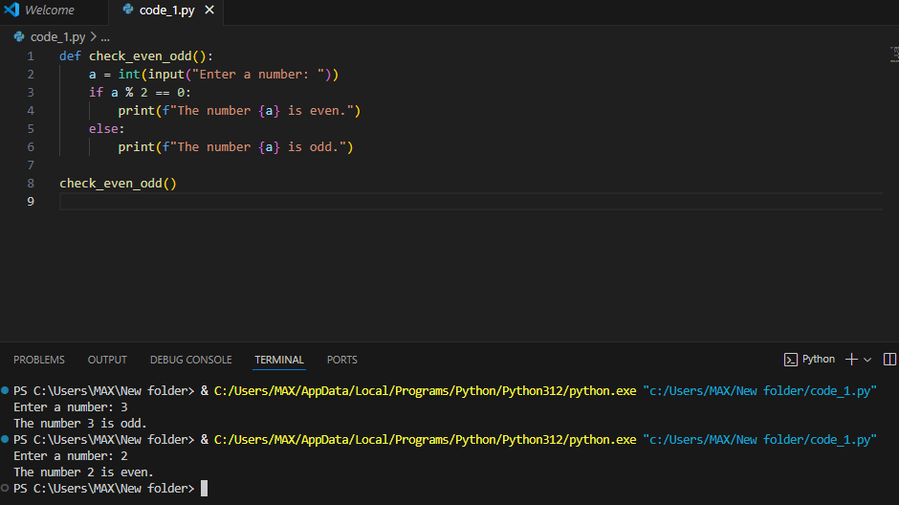

**Task No: (2)/ ATM machine**

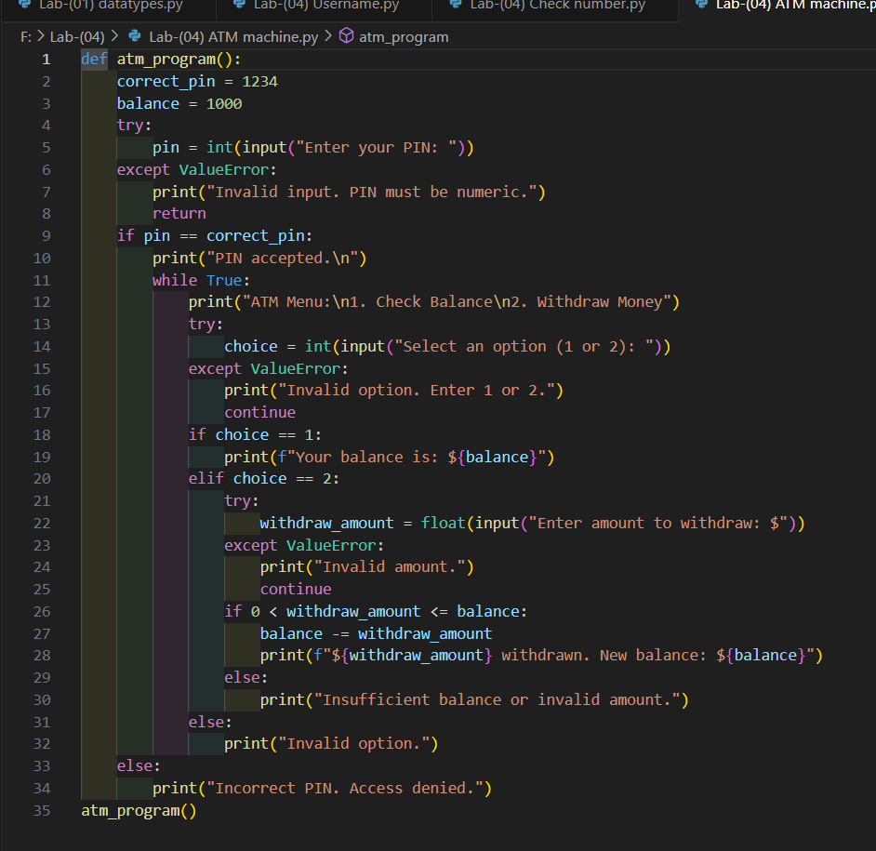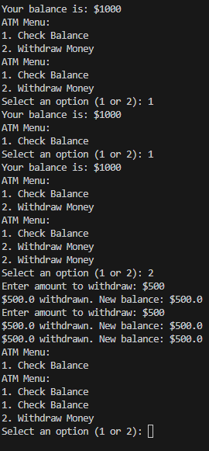

**Task No: (1)/ Login page**

